**Smoker Prediction Result:**

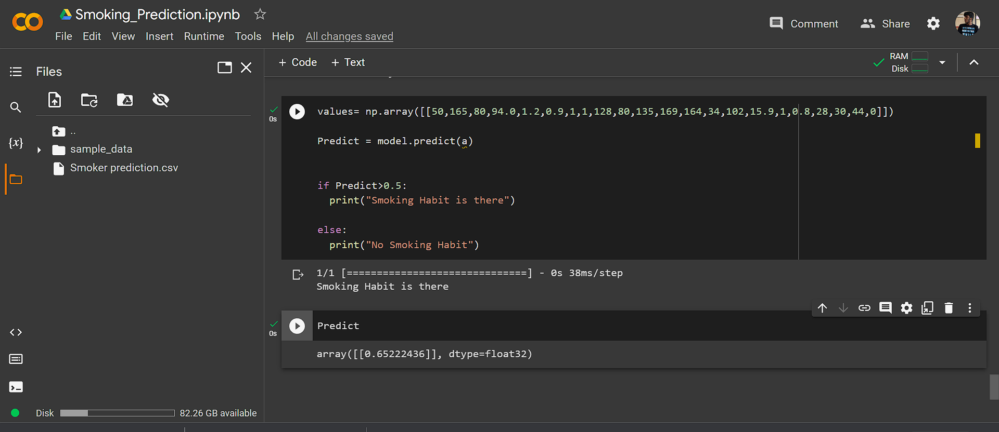

The result predicted the smoking habit if the given value is greater than 0.5